Front end

Home page -> student profile

->uploading page

-> it ,business management page , bio medical page

When you click it -> I will show the page of it department then you can select which module (web or mobile application)

Then I will show the filter for that so can filter it or search it -> click the preview &download -> download page

Home page

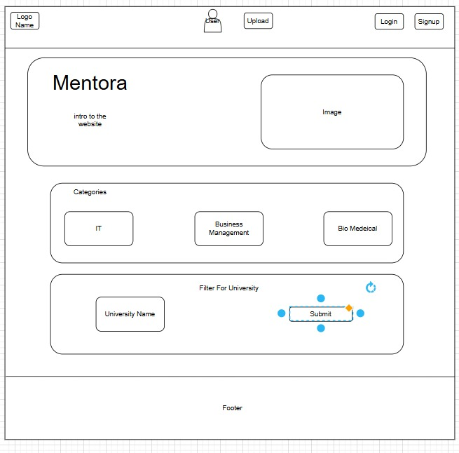

Department of It filter page

this page for website

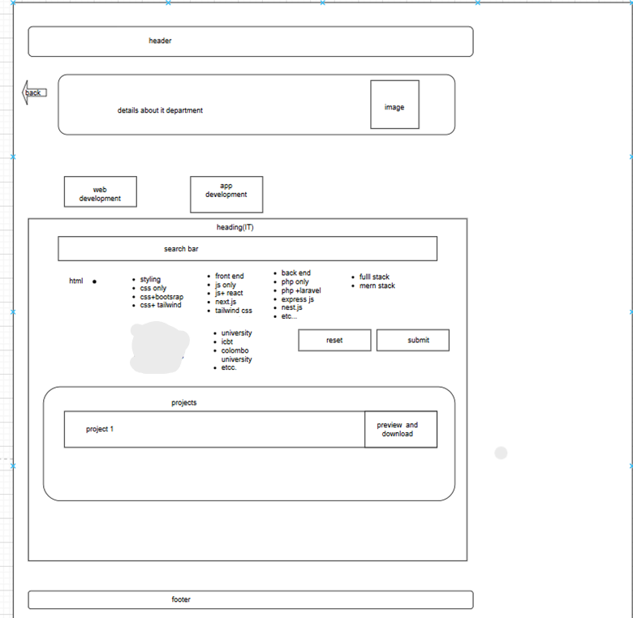

this page for mobile applications 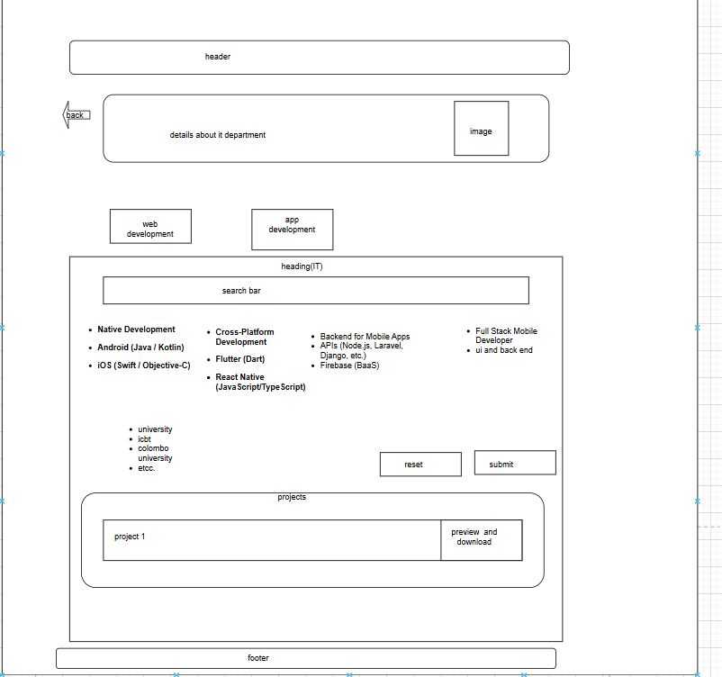

Department fo business management page

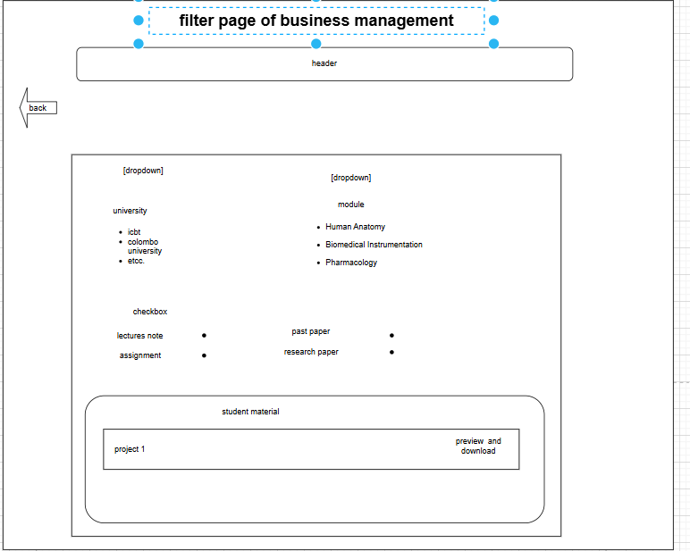

Department fo bio medical page

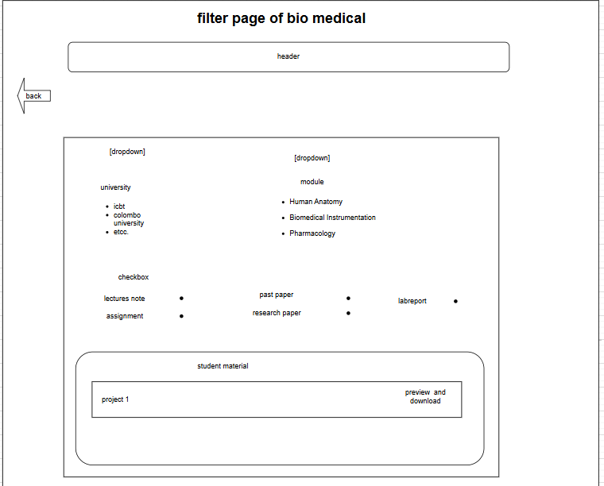

Major differences is lab report

Student profile

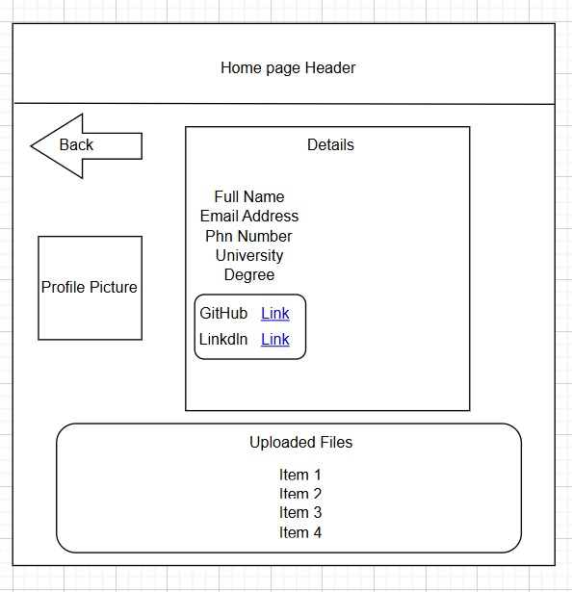

Uploading page

For it (web application)

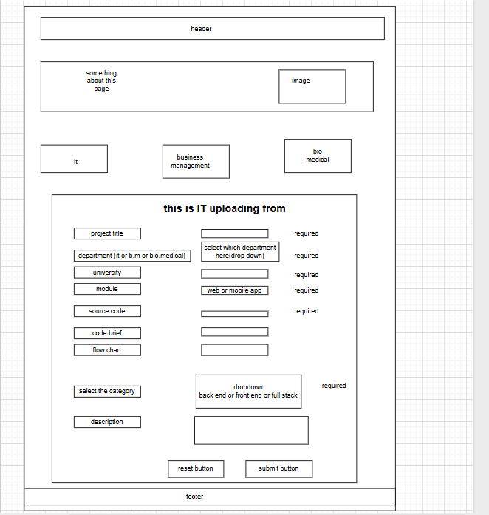

Select the category:

1. back end

2. front end

3. full stack

4.styling (css)

For it (mobile application)

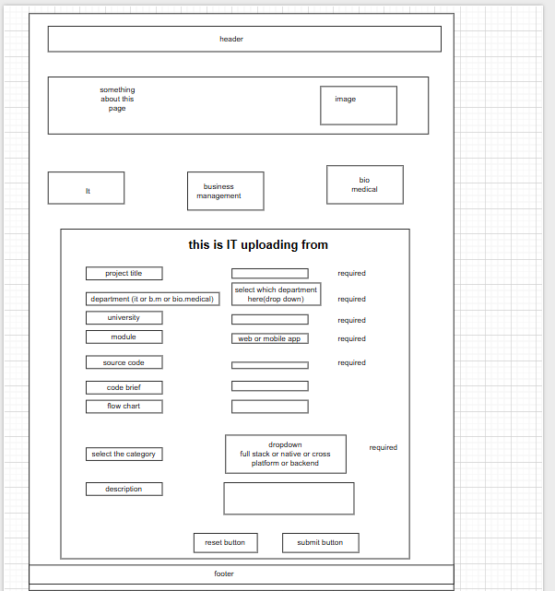

Select the category:

1. back end

2. native

3. full stack

4.cross platfrom

For business management

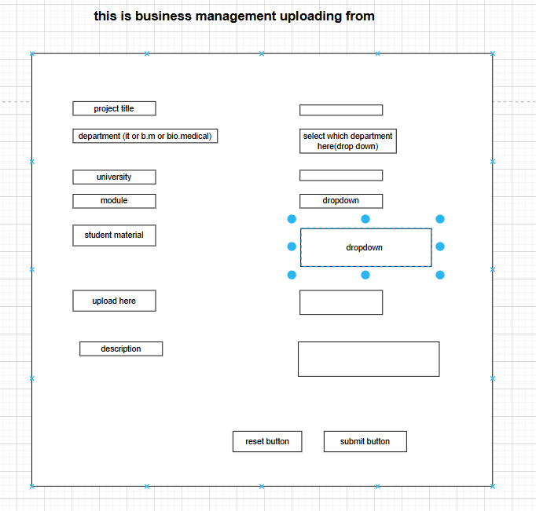

Module dropdown:

1. Marketing Management
2. Business Law
3. Financial Accounting

Student material dropdown

1.lectures notes

2.assignment

3.research paper

4.past paper

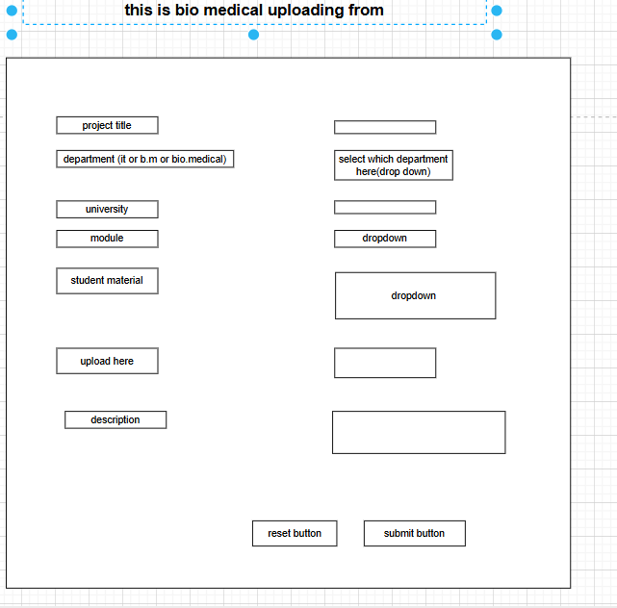

Module dropdown: Human Anatomy

Biomedical Instrumentation

Pharmacology

Student material dropdown :

1.lectures notes

2.assignment

3.research paper

4.past paper

5.lab report(bio medical)

Download the source

This is for it

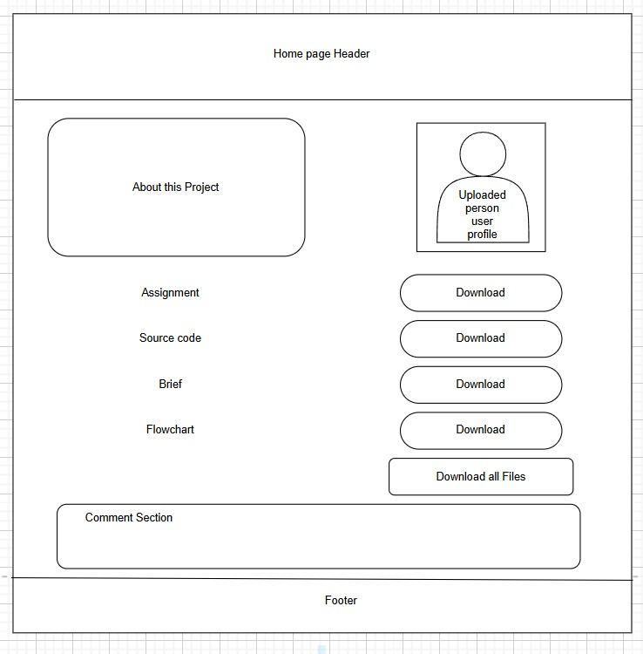

This is for business and bio medical

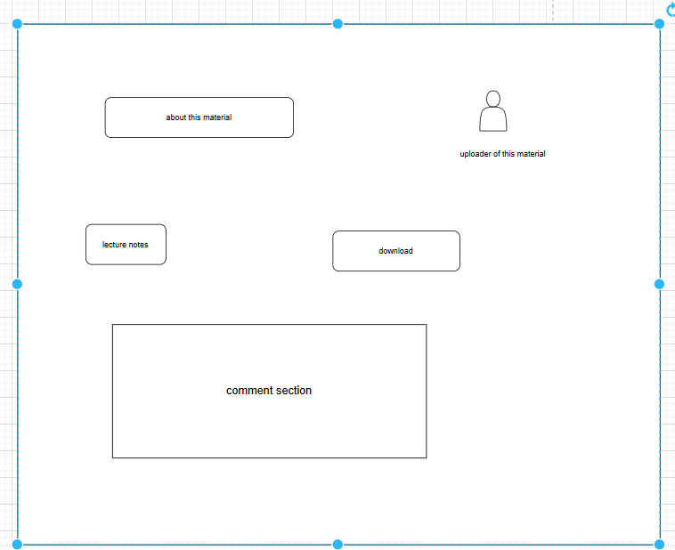

Same as assignment , research paper ,past paper ,labreport(only for bio)

Admin panel

1.dashboard overview

2.student management

3.manage uploads

4.manage university and module

5.comment moderation

6.logout )

1.dashboard overview

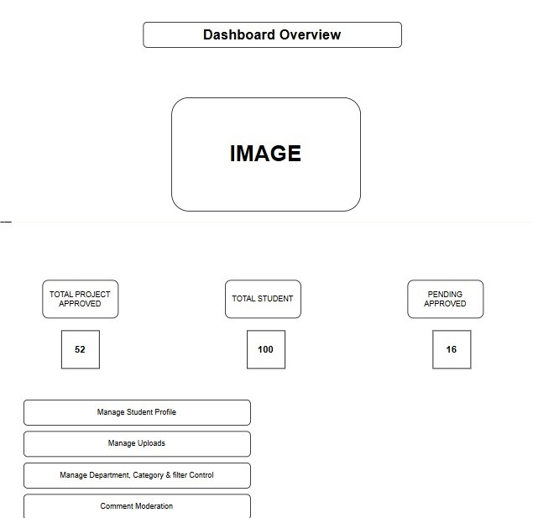



2.Manage student profile

Filter -> click action -> view full details of students -> action button -> student full details-> click specific project-> approvel status-> edit -> edit page

Filter and search bar option to find the student

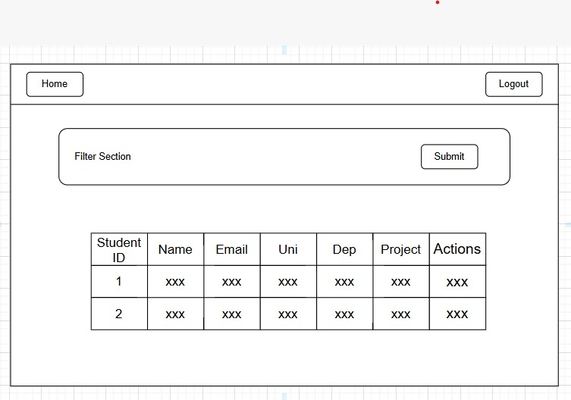

In the filter section :university, department, department,module,order by(newest to oldest and oldest to newset)

Dropdown method better option for filter

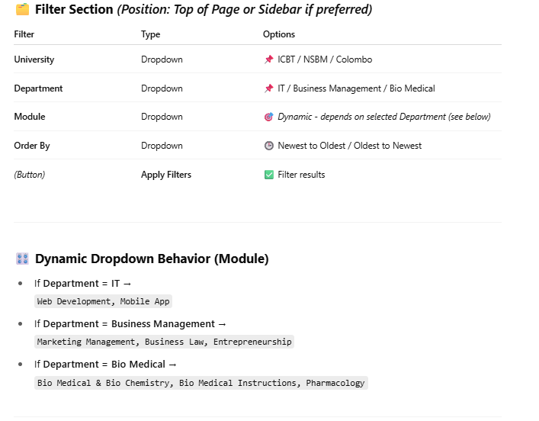

Full details of specific student

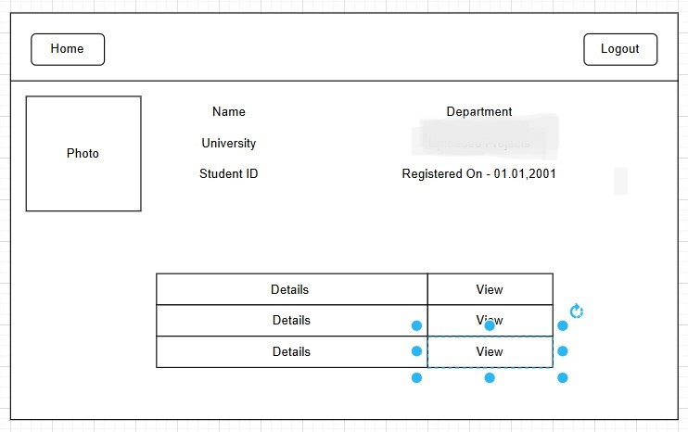

Note: under department you have to add module

Uploaded projects(heading) -must

|  |
| --- |
| Project title module (app or web) Details view(click it) |

Here you can see the approvel status

every full project view must content

1. Project title
2. university
3. Department(it or business or bio)
4. Module(web or mobile)
5. Student material:(front end or back end or native or lectures notes or past papers or research papers or lab report …… etc)
6. Updated on :date/month/year/time
7. Description

Somethings are missing below wireframe that is why im mentioning this

Full project details

Add :descriptions and department

Click the edit button

This is for bio medical and business management

1.Lecture notes

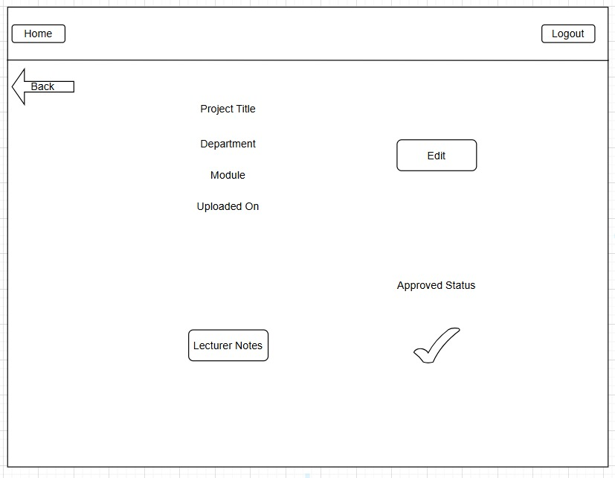

Add descriptions

2.Assignments

Add descriptions

3.researchpaper

Add descriptions

4.Past papers

Add descriptions

5.Lab report (only for bio medical)

Add descriptions

Here is the editing page

This page is for it

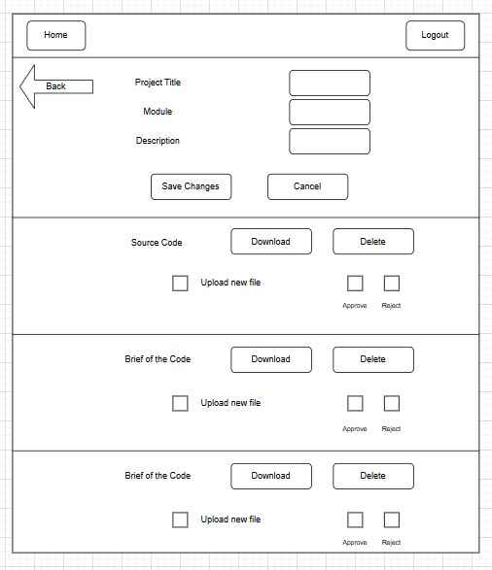

Note:

Project title

Department

Module,Description

This part also admin can edit

Edit page for business medical and bio medical

1.You can edit lectures notes here

2.You can edit assignment here

3.Research paper

4.Past paper

5.Lab report

**Edit Project Page Explanation**

This page allows the admin to edit an existing project that has been submitted for approval. Before entering this page, the admin can view the **Approval Status**, **Source Code**, **Brief Code**, **Flowchart**, and a **Correct/Incorrect** message for each section of the project.

**Features of the Edit Page:**

1. **Project Title**
   * The admin can **edit** the project title.
2. **Description**
   * The admin can **edit** the project description or summary.
3. **Source Code**
   * The admin can:
     + **Download** the existing source code file.
     + **Delete** the specific file.
     + **Upload** a **new** source code file if needed.
   * *Example*: If the **source code is already approved**, but the **brief code** or **flowchart** is **not approved**, the admin can edit and re-upload those specific sections.
4. **Approval Actions**
   * After making changes, the admin can:
     + **Save Changes**
     + **Approve/Reject** specific sections.
     + Updated approval statuses will be reflected on the project details page.

**Example Workflow:**

1. Admin clicks **Edit** → goes to **Edit Page**.
2. Admin edits the **title**, **description**, or **uploads** new files.
3. Admin **approves** or **rejects** the relevant parts.
4. Clicks **Save Changes** → Data goes to the **backend**.
5. Approval status is updated and displayed.

This ensures better control and flexibility in reviewing and managing submitted projects.

3.manage uploads

3.1 pending

3.2 approved

3.3 rejected

Select it -> click pending -> pending projects -> click action -> project details -> if you can you can edit :click edit -> edit page

every full project view must have this content and this how table should look like

1. Project title
2. university
3. Department(it or business or bio)
4. Module(web or mobile)
5. Student material:(front end or back end or native or lectures notes or past papers or research papers or lab report …… etc)
6. Updated on :date/month/year/time
7. Description

Somethings are missing below wireframe that is why im mentioning this

Example:->

| **Student ID** | **Name** | **Email** | **University** | **Department** | **Module** | **Material** | **Action** |
| --- | --- | --- | --- | --- | --- | --- | --- |
| 1001 | John Doe | john.doe@example.com | ABC University | IT | Web | Backend | View |

| **Student ID** | **Name** | **Email** | **University** | **Department** | **Module** | **Material** | **Action** |
| --- | --- | --- | --- | --- | --- | --- | --- |
| 1001 | John Doe | john.doe@example.com | ABC University | bio | pharmacology | Past paper | View |

3.1 pending page

Page 01

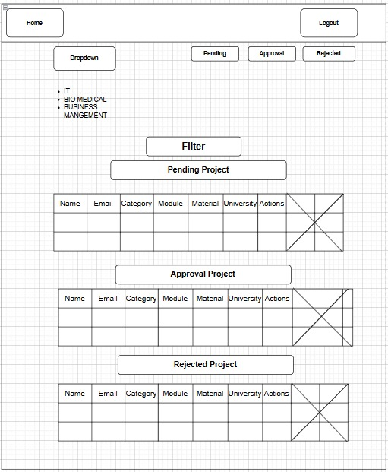

In this row,

Change category into department

Specific project details

This is for it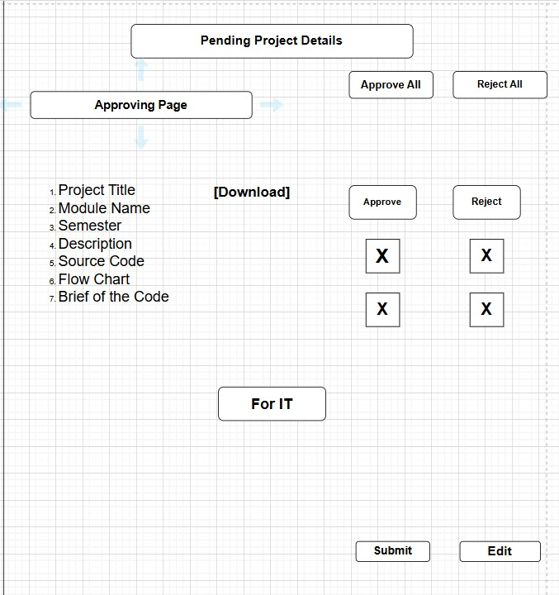

This is for business management

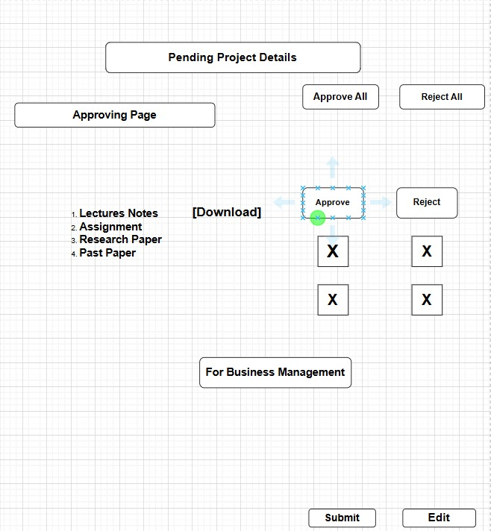

This is for bio medical

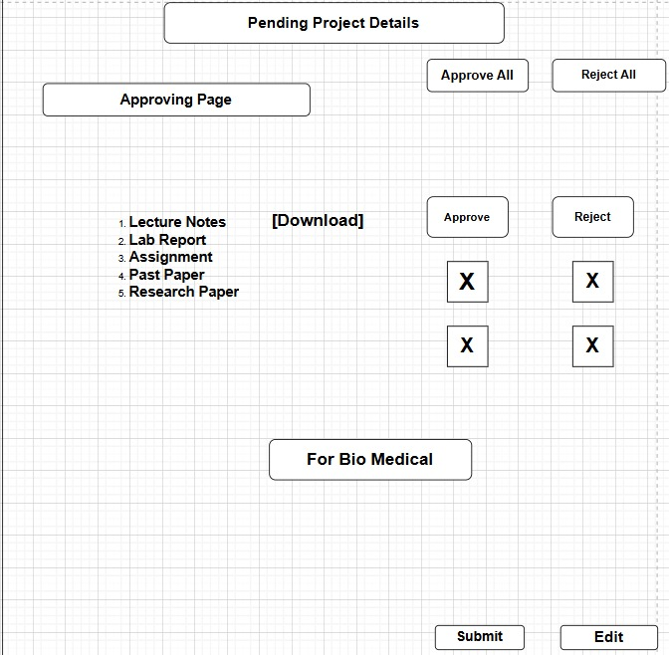

You can you download one by one

That download button will applied for lecture notes, lab report … etc so admin can download one by one and check if can be approve or reject

If you you want make any changes then click the edit so it direct to edit page so you can download edit anything from edit page

Edit page for it

Page 02



Edit page for bio medical and business management

Same idea of student page

3.2 Approved page

When you click the it or business or bio medical and click approved then you can see the approved projects

This is for business management

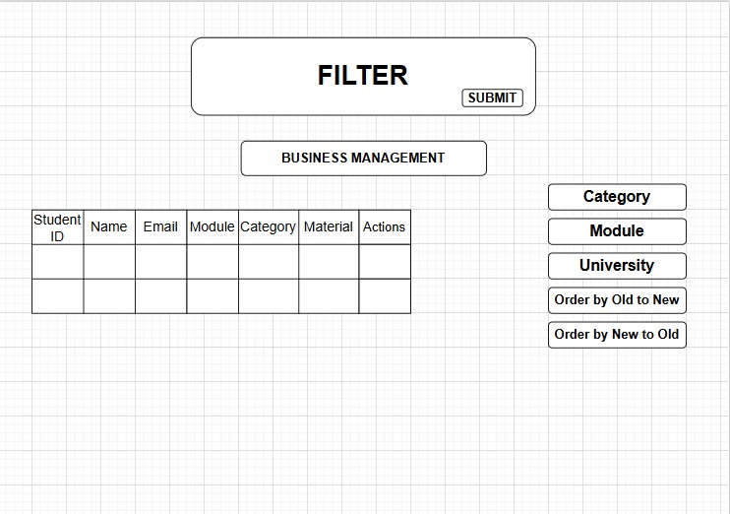

This is for bio medical

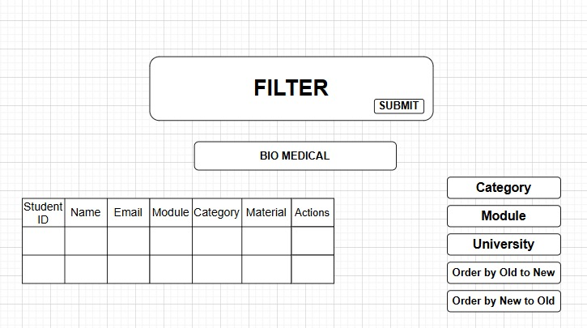

This is for it

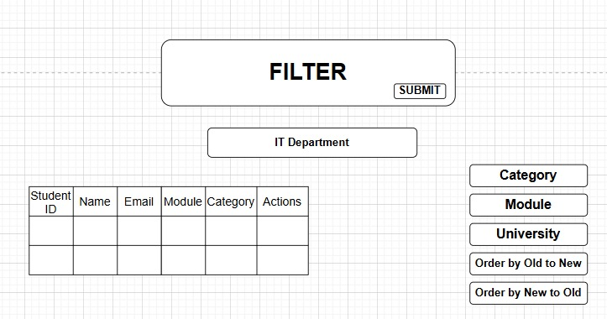

You click the actions you can see the full details approved status which is approved and which is not approved

This is for it

This is for business management

You can

Now you can see the approved status mark here

Same as assignment ,research paper, past paper, lab report

you can see edit page for reupload

this for it



Same idea of business .m and bio medical . we already did in manage student edit page

3.3Rejected

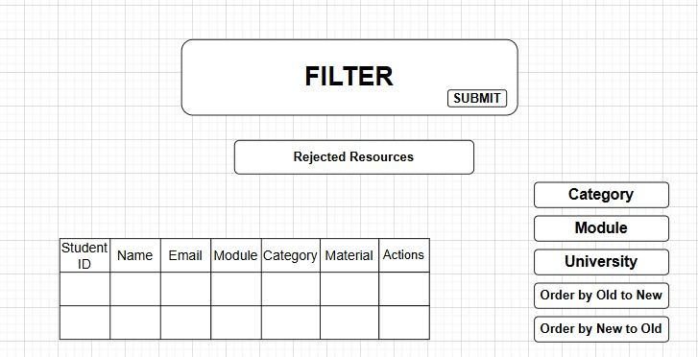

For it

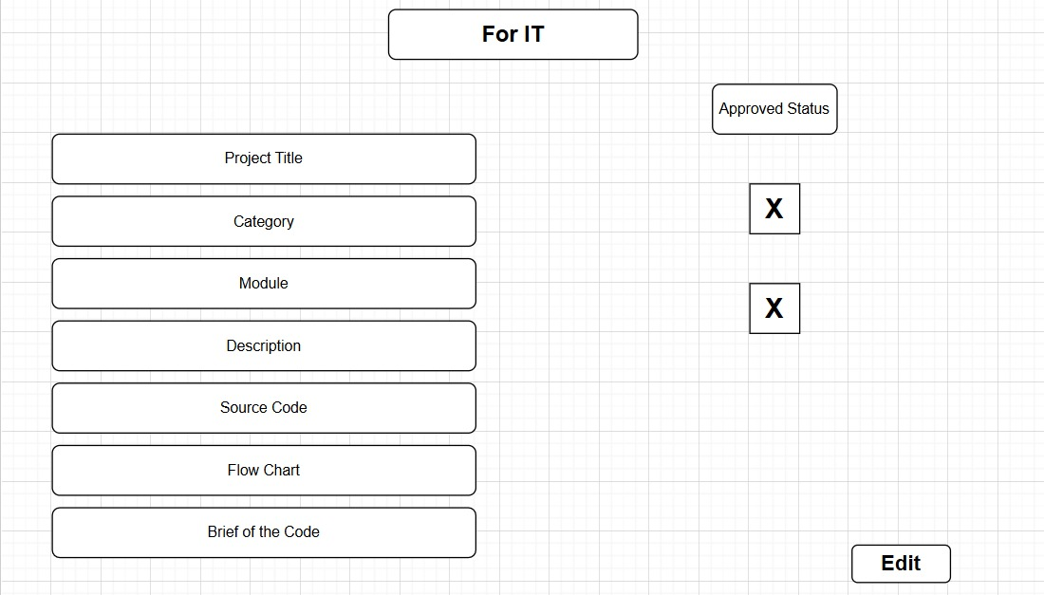

in this case all are rejected

For business management and bio medical

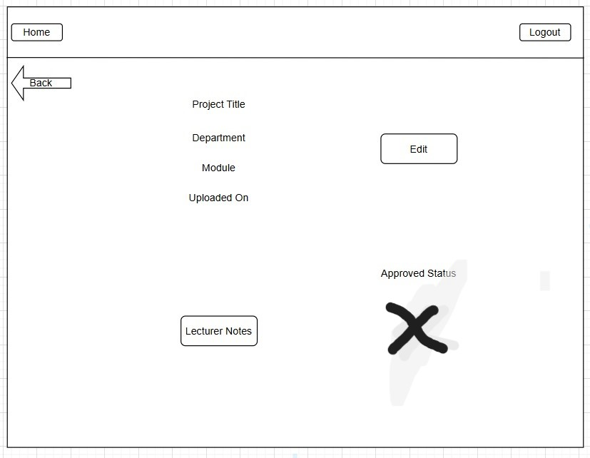

You see the x mark is here so this lecture note is rejected by admin

Same as assignment ,research paper, past paper, lab report

4.manage the university and module

4.1manage module

Click manage module +click it or business .m or bio .m -> existing module

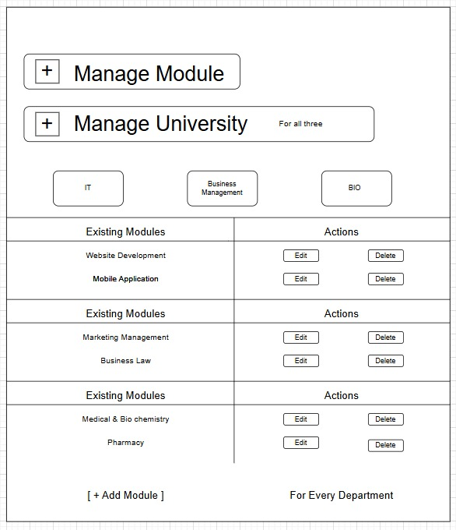

Click -> edit or delete if you click the edit button

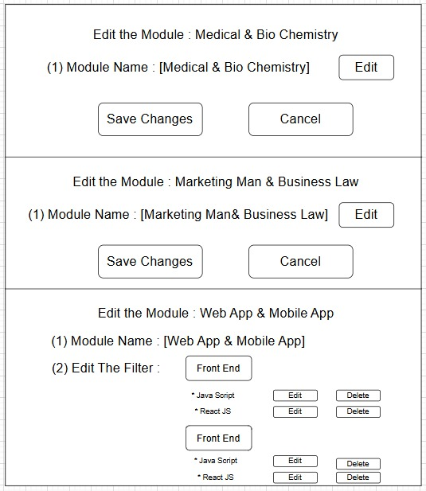

Note:I forget to add full stack under front end

When you click the add module

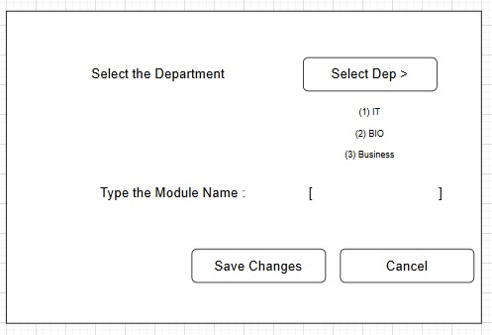

Then you select the which department and type the any name of the department

4.2 manage university

existing module

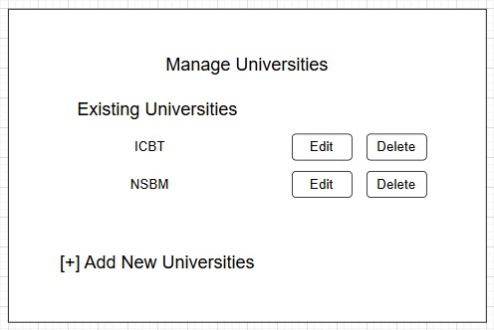

Edit the university

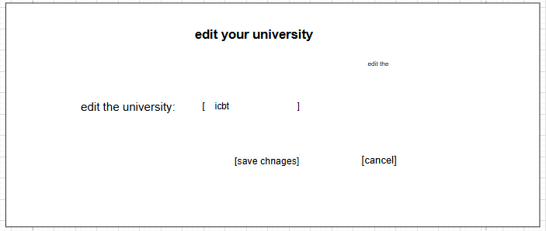

Add university

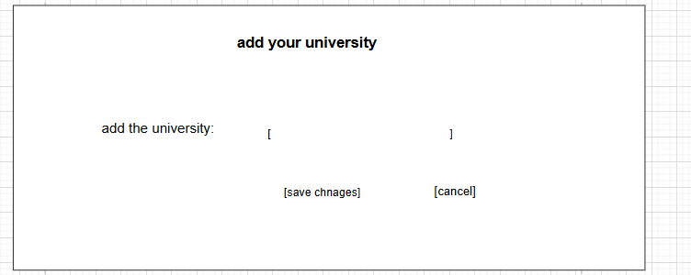

5.Manage comment section

Department:it,business management ,bio medical

Module : for it (web, mobile app)

For business.m(business law,marketing management,financial accounting )

For bio.m (pharmacology, medical and bio chemistry ,bio medical and instrumantation)

